Keyed & Dummy Handle Set for Entrance

This product is designed to provide a secure and stylish entrance to your home. With an adjustable hole distance, these handle Sets are compatible with most doors. The handle Sets are keyed alike, making it convenient to use the same key for multiple locks. Made with heavy-duty materials and featuring a matte black finish, they offer durability and a modern aesthetic.

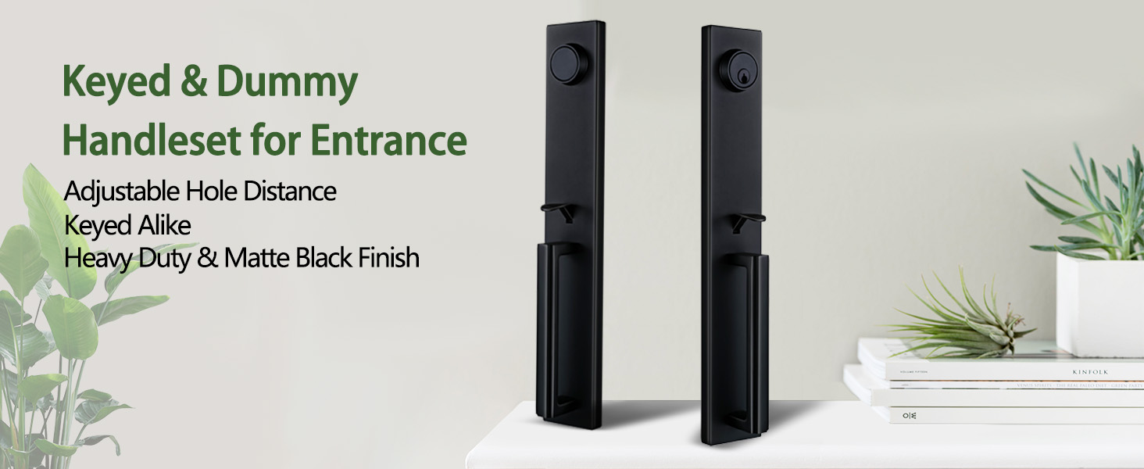

Keyed & Dummy Handleset for Entrance

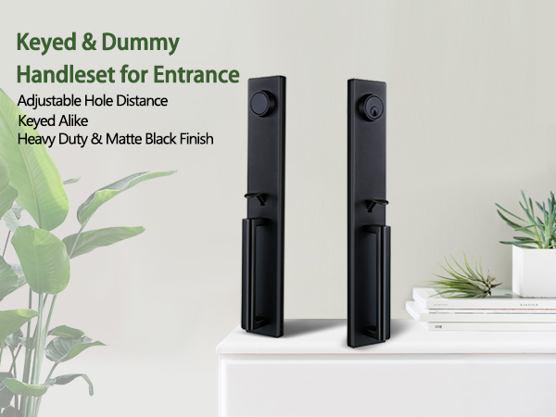

Adjustable Hole Distance



Heavy Duty & Matte Black Finish

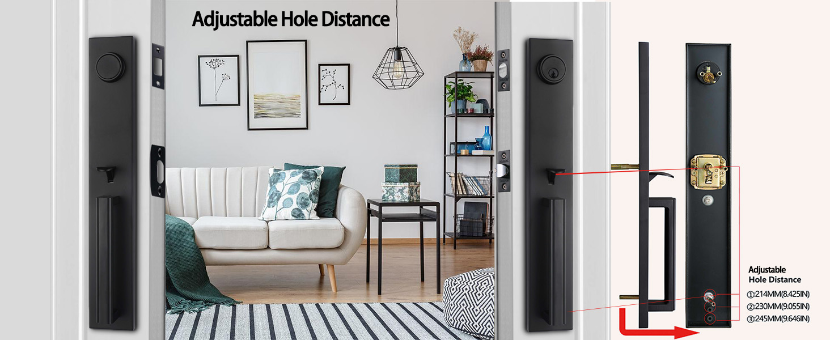

Suitable for Different Door Types

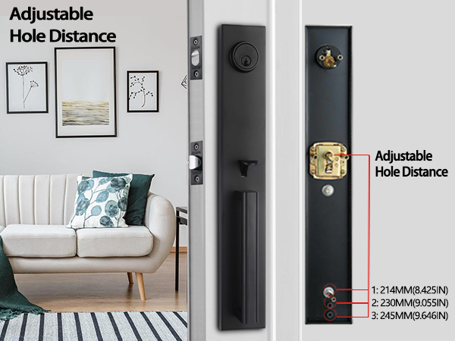

Keyed Alike Cylinders

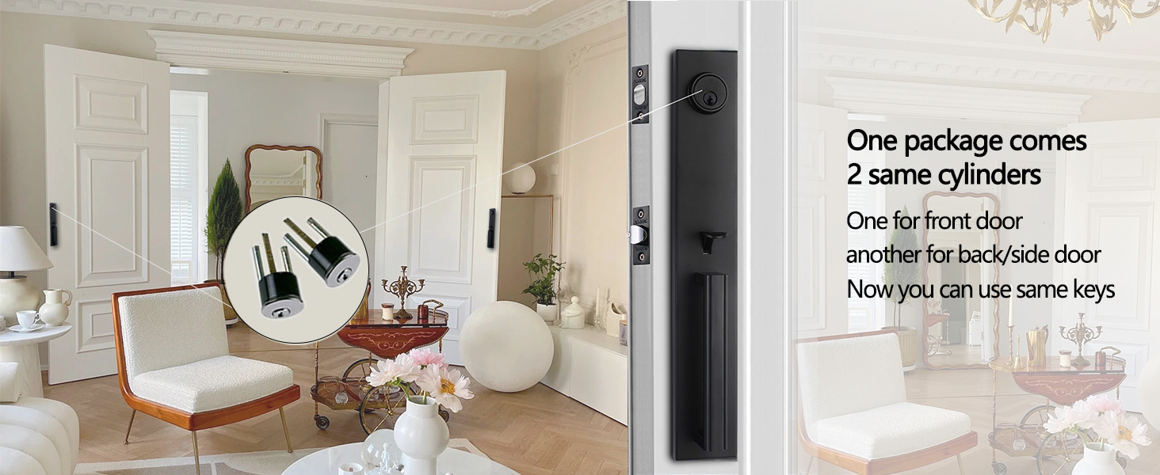

Modern Design for Elegant Entry